Me llamo _______________ Assessment
All About Me
Task: Create an “All about Me” character using the information learned in class. You are going to create an “All About Me” accordion figure in Spanish.

Instructions: These projects will be displayed. Be sure to use markers so that your writing will be visible!
1. Write the following information on each fold of the paper provided in FULL SPANISH SENTENCES:
- Name
- How you are feeling (based on how you appear/your emotion in the picture you have chosen to use.)
- Age
d. & e. Write a total of four (4) sentences, two (2) that describe you and two (2) things that you like to do
2. Using the provided template, cut out the arms and legs of your person.
3. Attach the arms and legs to the accordion body.
4. Attach your “face” (using your picture) to the top of the body.
5. After writing your rough draft of the project, re-read and edit your writing, then add your final work to the template provided.

Rough Draft of Project goes here:
a. _______________________________________________________
b. _______________________________________________________
c. _______________________________________________________
d. _______________________________________________________
e. _______________________________________________________
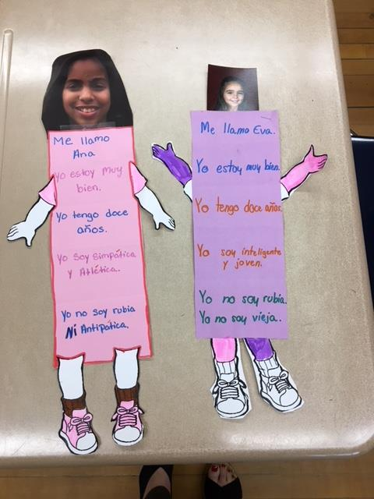
SAMPLE PROJECT:

“All about Me” Scoring Rubric
Total of 20 points
Nombre _________________________________
CATEGORY | 5 | 4-3 | 2 | 1-0
Content | Student provides accurate information about him/herself. | Most facts displayed on the poster are accurate. | Some sentences are accurate. | The sentences displayed on the poster are not accurate about the student.
Structure | There are no grammatical mistakes or very minor grammatical mistakes in subject/verb, noun/adjective, punctuation or spelling. | There are a few/several relatively minor grammatical mistakes in subject/verb, noun/adjective, punctuation or spelling. | There are several grammatical mistakes that somewhat impact overall comprehensibility due to subject/verb, noun/adjective, punctuation or spelling. | The grammatical mistakes in subject/verb, noun/adjective, punctuation or spelling make the project incomprehensible.
Vocabulary | Used vocabulary appropriately. The vocabulary relates to the topic. | Used most/some vocabulary appropriately. The vocabulary relates to the topic with some irrelevancies. | Some vocabulary was not used correctly and/or would not be understood by a native speaker. | Did not use appropriate vocabulary. Some components were translated, incomprehensible and/or not related to the topic.
Task Completion | Fully followed assembly directions.  Accomplished task by writing five full sentences about all five required topics.  The project is neat and sentences are clearly visible. | Partially followed assembly directions.  Accomplished task, but with some irrelevancies.  Project is assembled and sentences are somewhat visible. | Did not assemble correctly making the project incomplete.  Sentences have little connection to task.  Project is disorganized and sentences are difficult to read. | Project not complete.  Sentences are not connected to task and/or not completed.  Project is unorganized.
C COMMENTS AND SUGGESTIONS:
__________________________________________________________________________________________________________
__________________________________________________________________________________________________________

*All you need is to cut the arms and legs.
